Login Username – Arsenal98!

Login Password – Debraj (Encrypted as $2a$12$CWSRJb.sLN4LIyl987hIyO4PCL7SDcnoGNXttUQ6RHcuZQetsGtgW)

Role – Admin

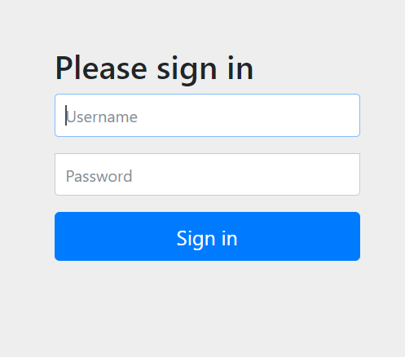

1. Adding Employees

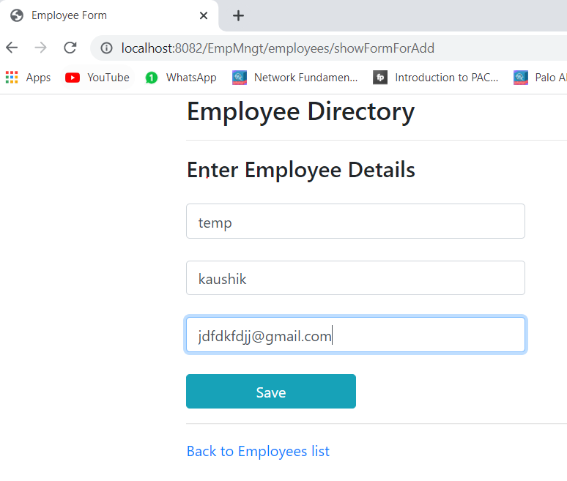

1. After adding two employees

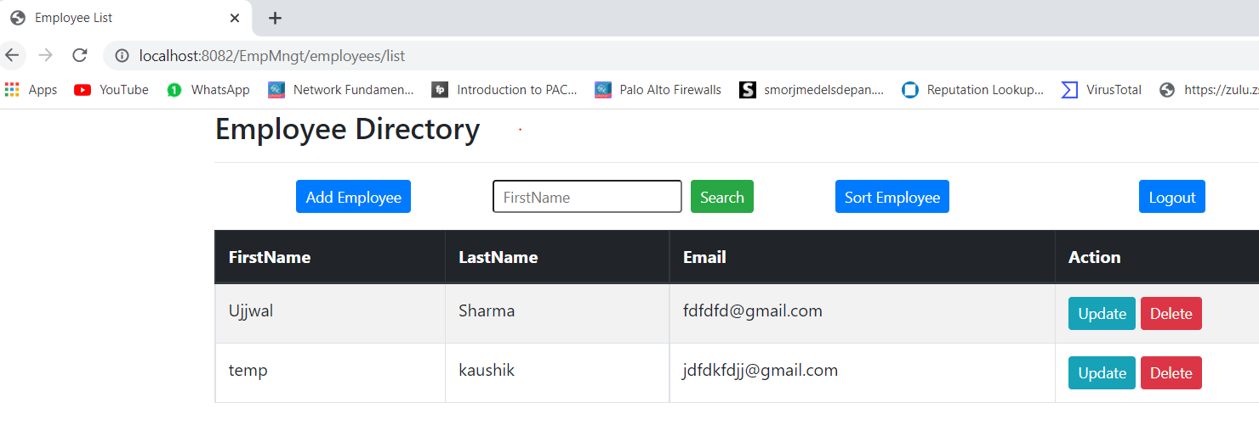

1. Clicking on update as shown

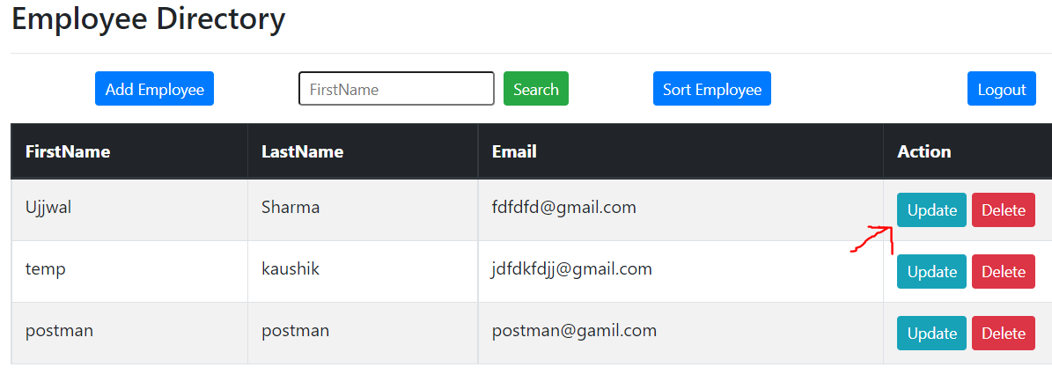

1. Update the particular employee

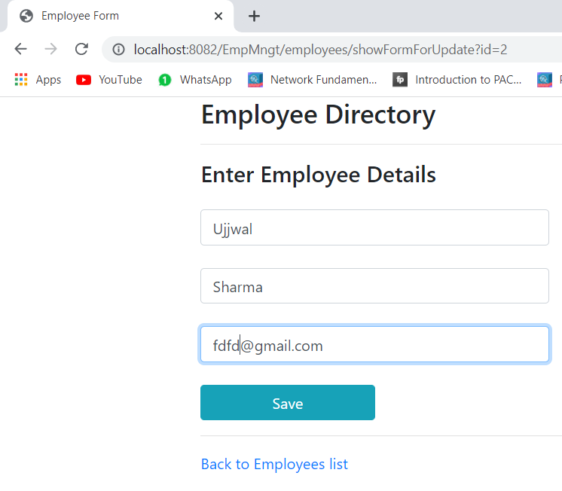

1. Updated email from [fdfdfd@gmail.com](mailto:fdfdfd@gmail.com) to [fdfd@gmail.com](mailto:fdfd@gmail.com)

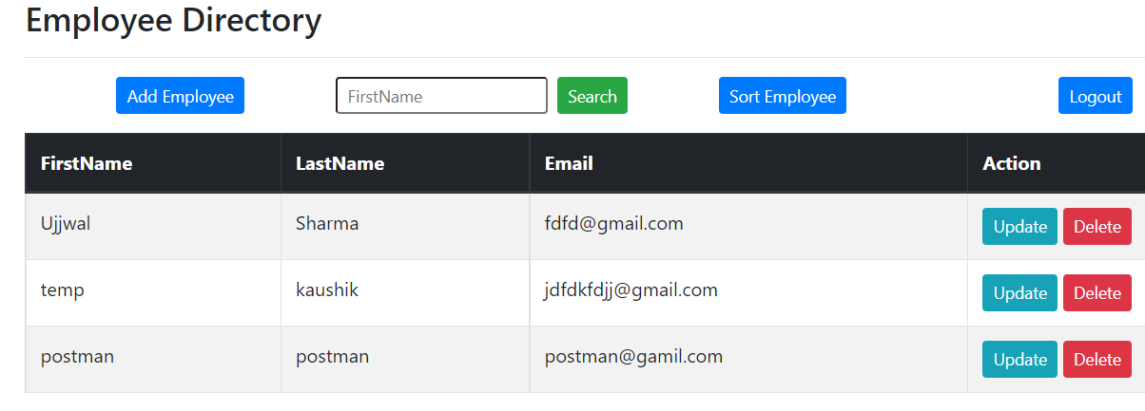

1. Clicking on delete option

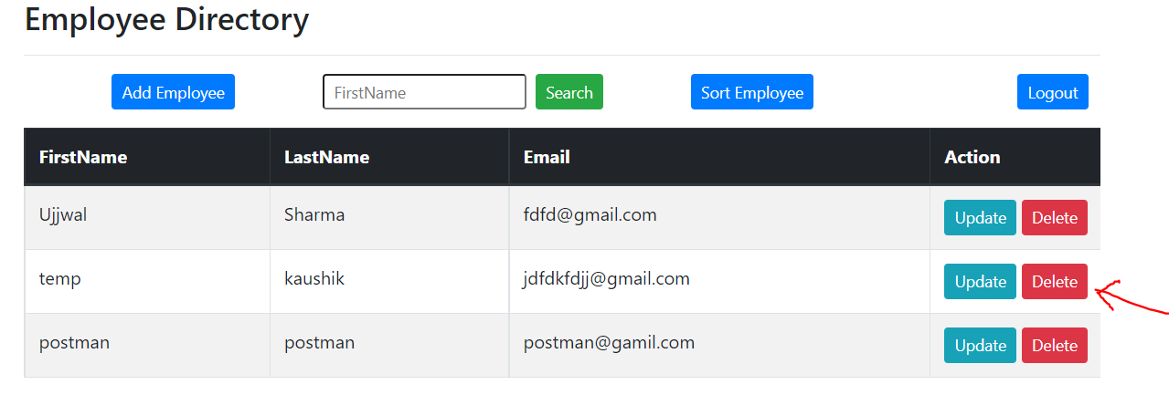

1. Pop up asking confirmation for deletion

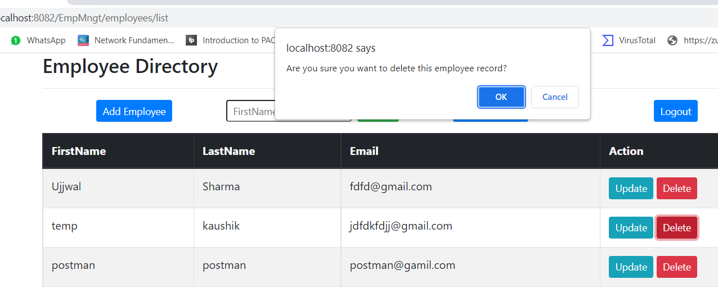

1. Deleted the particular record

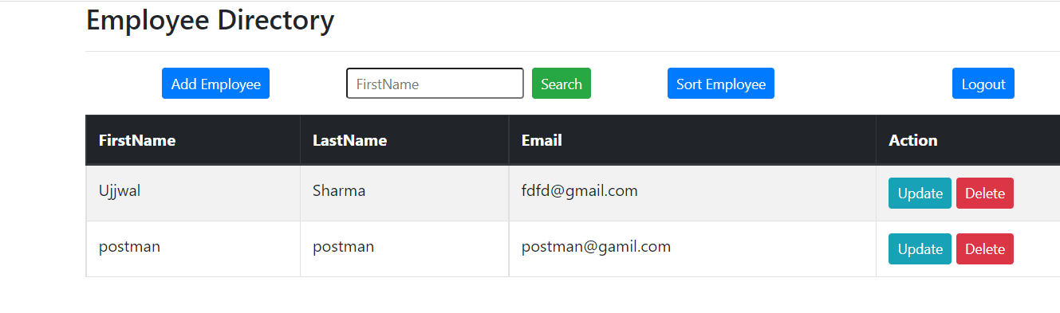

Login Username – Arsenal28!

Login Password – Nilesh (encrypted as $2a$12$zz3JlMFhk2AZBXVjLNa9w.fkTEc3IqlEC92HR70kUsqzRW2jdsnvG)

Role - User

1. Already two records were present, clicking on update option

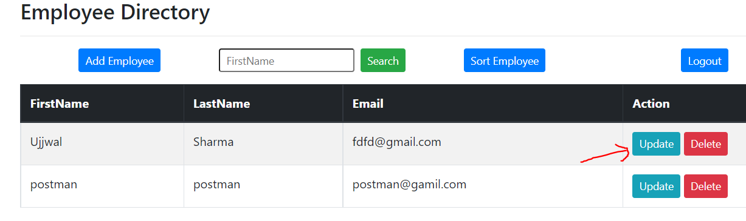

1. Gives Access Denied error as role is “User” so he is not having permission to update

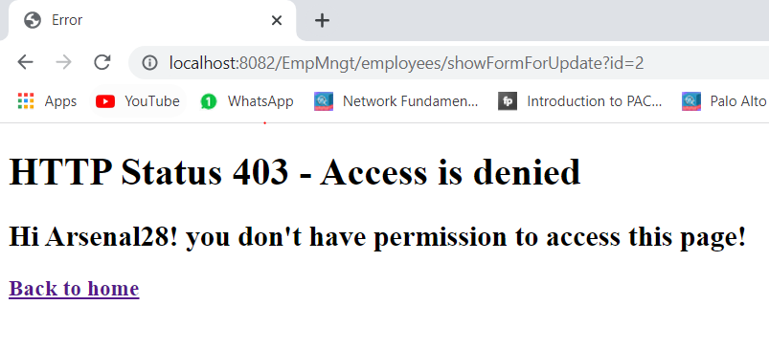

1. Clicking on delete option

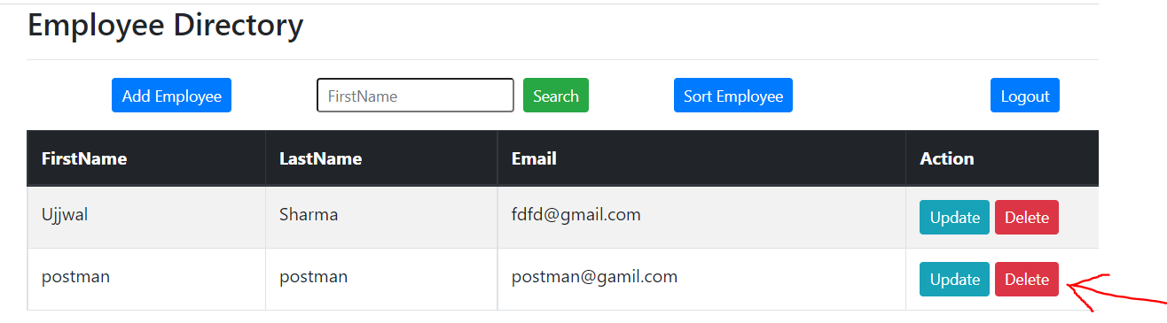

1. Giving pop up for confirmation of deletion

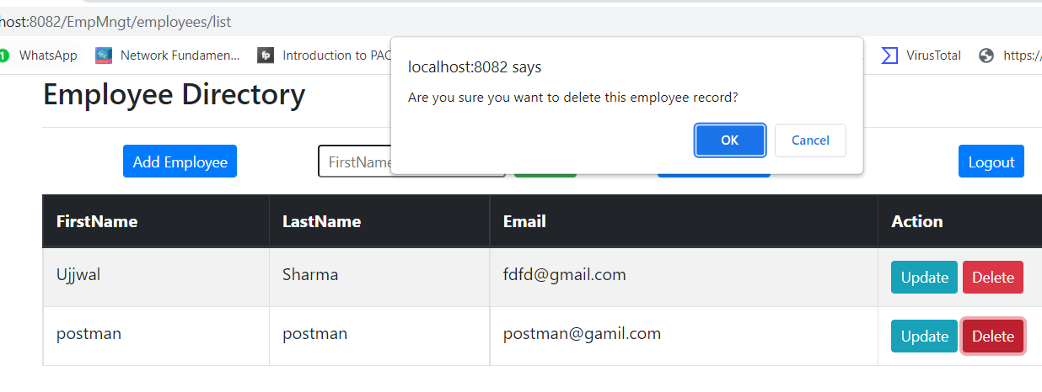

1. Gives Access Denied error as role is “User” so he is not having permission to delete

